Homework 2 Report

Wyatt Duberstein

This project was a bit tougher than Homework 1, but I enjoyed the programming part of it. Forgive my absolutely messy code, I’ve never touched JavaScript before so this was a bit experimental for me.

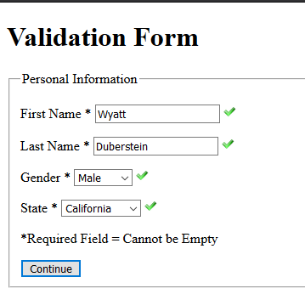For Validation Site 1, after programming the validation code, I put a piece of code in the validation.js file that, if all the fields are validated, waits 2 seconds before it moves to the next page. Here are the screenshots of both successful and failed inputs.

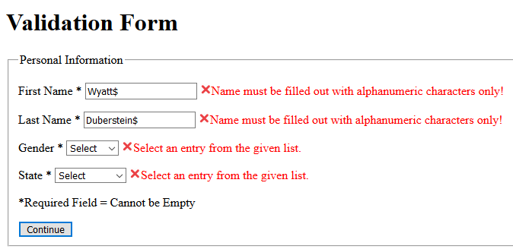

For the Validation site 2, I had to do a bit of tricky coding to make all of the input fields work. I had to make a method that checked alphanumeric-only inputs, alphabetic-only inputs, and numeric-only inputs. As well as a validation method for each form. The file length is pretty long, and the code here is even messier. I apologize. Here are the screenshots of both the successful and failed inputs.

